DATA COLLECTION & DATA CLEANING PROCESS STEPS
- Data successfully collected from the given source.
- Created a Table for each data set in Excel. (Customer Data, Product Data, Store Data & Sales Data.)
- By using Excel all the data from each table were cleaned by removing the Duplicate values, corrected the Formatting Errors with the help of Number Format option and replaced few data by using Replace Value option.
- Changed the data type for Date and Currency, Text and Number columns and Imputed all the missing data in each cell for all the table using Excel and also all the imputed cells were Highlighted.
- Imputed the data for loyalty level column from customer_db table in excel based on customers Age,City and State.
- Imputed values for Cost column and Stock column in product_db table.
- Imputed values for Quality column, Unit price column, Discount column and Total amount column in sales_db table.
- Created a new columns in sales_db table as Sales Performance.
- Created and new columns as Category, Product Name, Region, Loyalty Level & Month and combined these columns in Sales_db table using VLOOKUP function.

DESCRIPTIVE STATISTICS
Created a Descriptive Statistics for Total Amount Final column from the table sales_db.
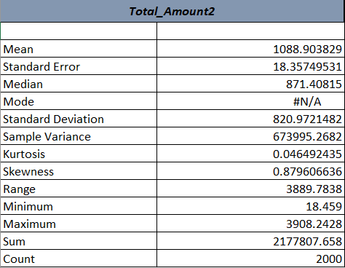

PIVOT TABLE
Created a Pivot Table in excel as category wise total revenue, loyalty level, month wise trends, region wise sales performance, payment type & top products.
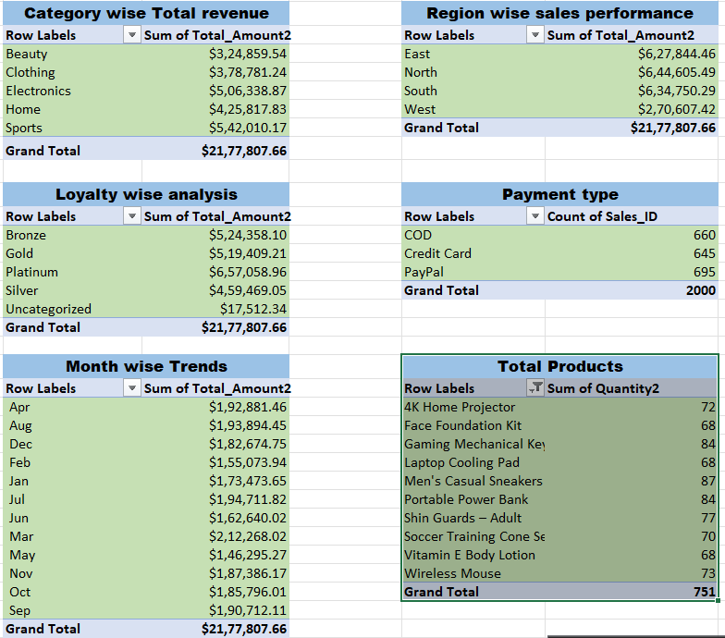

DATA VISUALIZATION
Created a Data Visualization in excel for all the pivot tables.
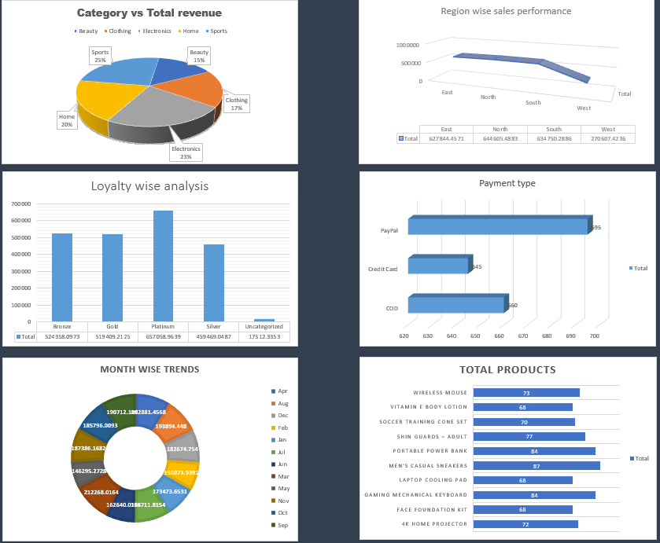

DASHBOARD
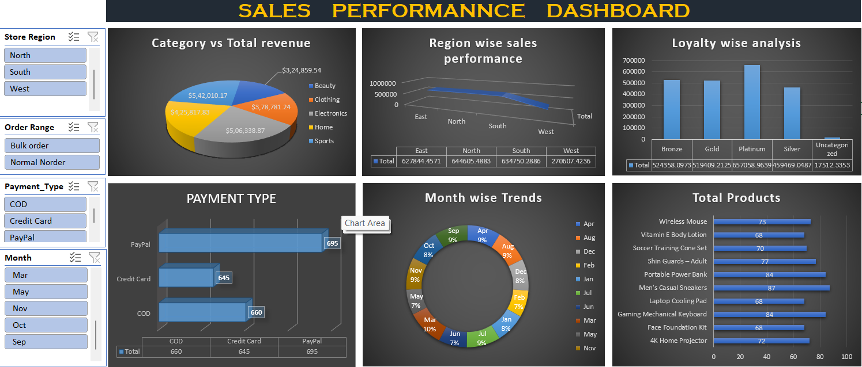

FUNCTIONS USED FOR DATA IMPUTATION
- =IF(ISBLANK([@Cost]),AVERAGEIFS([Cost],[Category],[@Category],[Sub_Category],[@[Sub_Category]]),[@Cost])
- =IF(ISBLANK([@Stock]),AVERAGEIFS([Stock],[Category],[@Category],[Sub_Category],[@[Sub_Category]]),[@Stock])
- =IF(ISBLANK([@Quantity]),AVERAGEIF([Product_ID],[@[Product_ID]],[Quantity]),[@Quantity])
- =IF(ISBLANK([@[Unit_Price]]),AVERAGEIF([Product_ID],[@[Product_ID]],[Unit_Price]),[@[Unit_Price]])
- =IF(ISBLANK([@Discount]),AVERAGEIF([Payment_Type],[@[Payment_Type]],[Discount]),[@Discount])
- =[@[Unit price Final]]*[@[Quantity Final]]*(1-[@[Discount Final]])
- =IFS([@[Total Amount Final]]>2500,"HIGH",[@[Total Amount Final]]>=1000,"MEDIUM",[@[Total Amount Final]]<1000,"LOW")
- =TEXT([@[Order_Date]],"mmm")

FUNCTIONS USED IN VLOOKUP
- =VLOOKUP(D:D,product_db,3,FALSE)
- =VLOOKUP(D:D,product_db,2,FALSE)
- =VLOOKUP(E:E,store_db,3,FALSE)
- =VLOOKUP(C:C,customer_db,9,TRUE)
- =TEXT([@[Order_Date]],"mmm")
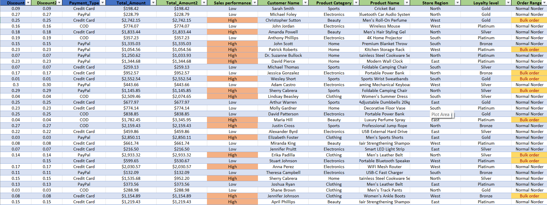
The above colums in Green colour are additional combined columns using VLOOKUP function.

E-Commerce Data Analysis – Summary
This project focuses on analyzing an E-commerce sales dataset using Microsoft Excel. The main objective was to clean the data, analyze sales performance, and visualize important business insights through charts and dashboards.
1. Data Collection and Cleaning
The data was collected from different datasets including Customer Data, Product Data, Store Data, and Sales Data.
The following cleaning steps were performed:
Removed duplicate values to maintain data accuracy.
Corrected formatting errors using Excel number formatting options.
Replaced incorrect values using the Replace Value feature.
Updated the data types for columns such as Date, Currency, Text, and Numbers.
Handled missing values (data imputation) in different tables.
Highlighted the cells where data was imputed for transparency.
Additional improvements:
Filled missing values in Cost and Stock columns in the product table.
Filled missing values in Quantity, Unit Price, Discount, and Total Amount in the sales table.
Added new columns such as Sales Performance, Category, Product Name, Region, Loyalty Level, and Month using the VLOOKUP function.
2. Descriptive Statistics
Descriptive statistics were created for the Total Amount Final column to understand sales distribution.
Key insights:
Average (Mean) Sales: ~1086.5
Median Sales: ~870.18
Standard Deviation: ~818.29 (indicates variation in sales values)
Minimum Sales: 18.45
Maximum Sales: 3908.24
Total Sales: 2,173,018.35
Total Transactions: 2000
This analysis helps understand the overall sales behavior and variability.
3. Pivot Table Analysis
Pivot tables were created to analyze sales from different perspectives:
Category-wise Total Revenue
Loyalty Level Revenue
Monthly Sales Trends
Region-wise Sales Performance
Payment Type Distribution
Top Selling Products
These pivot tables help quickly summarize large datasets and identify patterns.
4. Data Visualization
Charts were created in Excel to visually represent the pivot table results:
Category vs Total Revenue (Pie Chart)
Payment Type Distribution (Bar Chart)
Monthly Sales Trends (Donut Chart)
Region-wise Sales Performance (Bar Chart)
Loyalty Level Analysis (Line Chart)
Top Products Analysis (Bar Chart)
Visualization makes the sales insights easier to understand.
5. Sales Performance Dashboard
An interactive sales dashboard was created to present key insights in one place.
The dashboard includes:
Category revenue analysis
Payment method distribution
Monthly sales trends
Region-wise sales performance
Loyalty level analysis
Top selling products
It also includes filters for Region and Loyalty Level, allowing users to interactively analyze the data.

Conclusion
This project demonstrates how Excel can be used for data cleaning, analysis, and visualization. By using formulas, pivot tables, descriptive statistics, and dashboards, the dataset was transformed into meaningful business insights that help understand sales performance and customer behaviour.

